Generative AI is a type of artificial intelligence that can create new content — such as text, images, audio, video, code, or even data — based on patterns it has learned from large amounts of information.
🌟 In simple terms
Generative AI models learn from examples and then generate something new that resembles those examples.

🔍 How it works
Generative AI uses machine-learning models (like GPT, diffusion models, or transformers) that:
- Learn patterns from huge datasets
(e.g., conversations, images, music)
- Understand relationships
(e.g., how sentences or images are typically structured)
- Predict what comes next
(e.g., the next word in a sentence or the next pixel in an image)
- Create new output
(a paragraph, a painting, a song, code, etc.)

🧠 Examples of what generative AI can do
- Write emails, essays, and summaries
- Generate images from text prompts
- Create chatbots that respond naturally
- Make music or voiceovers
- Help design products, logos, and UI layouts
- Generate code or troubleshoot errors

📌 Popular generative AI tools
- ChatGPT / Copilot – text and conversation
- DALL·E / Midjourney / Stable Diffusion – images
- GitHub Copilot – code generation
- Suno / MusicGen – music and audio generation

🧩 Why it’s important
Generative AI is transforming industries by:
- Automating repetitive creative tasks
- Boosting productivity
- Helping people without technical skills create content
- Enabling personalized experiences

Generative AI is a subset of artificial intelligence that focuses on creating new content rather than merely analyzing existing data. Here are the key aspects of generative AI:
- Creation of New Content: Unlike conventional AI, which typically analyzes data to make predictions or categorizations, generative AI generates original outputs. This can include text, images, audio, video, and even code.
- Use of Deep Learning: Generative AI utilizes deep learning methods, specifically neural networks, to understand patterns in training data. It learns from large datasets to produce fresh content that wasn't explicitly programmed beforehand.
- Handling Ambiguity: Generative AI can manage more complex, open-ended tasks, allowing it to generate diverse and creative solutions based on learned information.
- Applications: Examples of generative AI applications include chatbots like ChatGPT, image generators like DALL-E, and various code generation tools.
In summary, generative AI expands the capabilities of artificial intelligence by synthesizing new content using learned patterns rather than just referring back to existing data.

Here’s a clear, easy-to-understand comparison of Generative AI vs. Traditional AI.

🤖 Generative AI vs. Traditional AI
1. Purpose
Traditional AI:
- Focuses on analysis, classification, and decision-making.
- It answers questions like “Is this a cat?”, “Is this transaction fraudulent?”
- It’s mainly predictive.
Generative AI:
- Focuses on creation.
- It creates new text, images, audio, code, or designs.
- It’s mainly creative and generative.

2. Output
Traditional AI produces:
- Labels (spam / not spam)
- Scores (credit score)
- Recommendations (watch this movie)
- Predictions (weather tomorrow)
Generative AI produces:
- An entire email
- A photo-realistic image
- A poem, summary, or video
- A piece of music
- Computer code

3. Data Usage
Traditional AI:
- Learns patterns to make correct predictions.
- Needs structured data (numbers, tables) more often.
Generative AI:
- Learns patterns to imitate and create content.
- Trains on huge volumes of unstructured data (text, images, audio).

4. How They Work
Traditional AI models include:
- Decision trees
- Linear/logistic regression
- Rule-based systems
- Classic machine learning
Generative AI models include:
- Large Language Models (LLMs) like GPT
- Diffusion models (for images)
- GANs (Generative Adversarial Networks)
- Transformers (architecture behind modern AI)

5. Interaction Style
Traditional AI:
- Limited, task-specific.
- Answers in short outputs (Yes/No, labels, numbers).
Generative AI:
- Conversational, multi-turn, human-like.
- Can produce paragraphs of reasoning, stories, or detailed answers.

6. Flexibility
Traditional AI:
- Designed for a single task.
- A fraud detection model can't suddenly start recognizing faces.
Generative AI:
- Highly flexible and multi-purpose.
- The same model can:
  - write an email
  - summarize a PDF
  - generate an image
  - answer questions
  - write code
  - translate languages

Quick Summary Table
Feature | Traditional AI | Generative AI
Goal | Predict/decide | Create/produce
Output | Labels, scores, predictions | Text, images, audio, code
Data | Often structured | Mostly unstructured
Models | Classic ML | LLMs, GANs, Diffusion
Flexibility | Narrow | Very broad
Examples | Spam filter, credit scoring | ChatGPT/Copilot, image generators

Generative AI is already being used across industries, often in ways that save time, reduce cost, and unlock new possibilities that weren’t practical before. Here are the most impactful real-world applications today:

🌍 Real-World Uses of Generative AI
1. Content Creation (Text, Images, Audio)
- Writing emails, blogs, marketing copy
- Creating images, illustrations, logos, and product mockups
- Generating music, voiceovers, and sound effects
- Drafting scripts, summaries, or storyboards
Where it’s used:
Marketing teams, media companies, designers, social media managers.

2. Customer Support & Virtual Assistants
- AI chatbots that answer customer queries
- Automatic ticket summarization
- Sentiment analysis and response drafting
Used by:
Banks, e-commerce platforms, telecom companies, healthcare providers.

3. Software Development & IT Automation
- Writing and debugging code
- Generating documentation
- Automating test case creation
- Suggesting improvements to existing code
Examples:
GitHub Copilot, Microsoft Copilot in Visual Studio.

4. Design, Architecture & Manufacturing
- Generating 3D models
- Product design suggestions
- Simulating prototypes
- Creating interior design concepts
Industries:
Automotive, consumer electronics, construction, gaming.

5. Healthcare
- Drafting clinical notes from doctor–patient conversations
- Creating medical imaging enhancements
- Drug discovery via molecule generation
- Personalized treatment recommendations (with human oversight)
Used by:
Hospitals, biotech companies, research labs.

6. Education & Training
- Personalized tutoring
- Practice exams and quizzes
- Lesson plan generation
- Explainer videos and simulations
Used by:
Schools, universities, corporate training teams.

7. Finance & Banking
- Generating financial summaries and reports
- Detecting anomalies by learning typical patterns
- Creating investment research drafts
- Automating compliance documentation

8. Gaming & Entertainment
- Generating characters, storyline scripts, and worlds
- Creating background music and sound effects
- Building new levels or assets
Used by:
Game studios, VFX companies, animation teams.

9. Marketing & Sales
- Personalized ads and product descriptions
- Audience segmentation
- Email campaign generation
- Social media post creation

10. Business Operations & Productivity
- Meeting notes and action items
- Document summarization
- Language translation
- Workflow automation
Tools used:
Microsoft 365 Copilot, Google Workspace AI, Notion AI.

✨ Why these uses matter
Generative AI helps organizations:
- Save hours on repetitive tasks
- Improve creativity and innovation
- Reduce costs
- Increase personalization
- Speed up product development

Here’s a clear, simple, and easy-to-remember explanation of Artificial Intelligence (AI), Machine Learning (ML), and Deep Learning (DL) — and how they relate to each other.

🤖 1. Artificial Intelligence (AI)
AI is the broad field of making machines think and act like humans.
It includes any computer system that can perform tasks such as:
- Understanding language
- Recognizing images
- Solving problems
- Learning from data
- Making decisions
👉 AI = the big umbrella.
ML and DL both fall inside AI.

📘 2. Machine Learning (ML)
Machine Learning is a subset of AI where machines learn from data instead of being explicitly programmed.
In simple terms:
ML uses data to make predictions or decisions.
Examples:
- Netflix recommending movies
- Email spam detection
- Predicting house prices
- Fraud detection in banking
ML models learn patterns from data and improve over time.
👉 ML = AI that learns from data.

🧠 3. Deep Learning (DL)
Deep Learning is a subset of Machine Learning that uses neural networks with many layers (called deep neural networks).
Deep Learning excels when:
- Data is large (millions of images/text)
- Patterns are complex
- High accuracy is needed
Examples:
- Self-driving car vision
- Face recognition
- Voice assistants (Siri, Alexa)
- Generative AI (like ChatGPT, image generators)
👉 DL = ML using deep neural networks.

🔁 How they relate (simple analogy)
Think of AI, ML, and DL like this:
AI → The discipline (the whole universe)
ML → A technique within AI (a solar system)
DL → A technique within ML (a planet)
Or another way:
- AI = The goal
- ML = The method
- DL = A specialized method using neural networks

📝 Quick comparison table
Concept | What it is | Examples
AI | Machines that simulate human intelligence | Chatbots, robots, smart assistants
ML | AI that learns from data | Spam filter, recommendations
DL | ML using multi-layer neural networks | Face recognition, generative AI

Machines learn through a process that can be broken down into several key steps:
- Data Collection: Machines rely on large datasets to learn. This data can be structured (like spreadsheets) or unstructured (like images or text).
- Training: Machine Learning (ML) involves training algorithms on this data. The machine uses different techniques to identify patterns and relationships in the data. For example, a machine may learn what an "apple" is by analyzing numerous images labeled as apples, bananas, and oranges.
- Algorithms: Various algorithms are used in ML, including decision trees, support vector machines, and neural networks. These algorithms define how the machine processes information and learns from it.
- Learning from Experience: Similar to how humans learn through experience, machines improve their performance over time by adjusting their predictions based on feedback, often referred to as supervised learning (where labeled data is used) or unsupervised learning (where the machine finds patterns without labeled data).
- Making Predictions: Once trained, machines can make predictions or decisions based on new data. For instance, after learning about fruits, a machine can identify a new fruit as an apple if it shares characteristics with the data it was trained on.
By these means, machines incrementally build their understanding and improve their effectiveness at specific tasks, advancing their capabilities through continuous learning and adaptation.
Neural networks
are a fundamental component of modern machine learning, inspired by the way the human brain processes information. Here’s a breakdown of their key characteristics:
- Structure: Neural networks consist of layers of interconnected nodes (or neurons). Each node processes input data, typically combining multiple inputs, applying weights (importance factors), and passing the results through an activation function to produce an output.
- Layer Types:
  - Input Layer: This layer receives raw data, such as pixel values from an image.
  - Hidden Layers: These layers perform transformations on the data through multiple computations, allowing the network to learn complex patterns. For example, different nodes in these layers could detect various features, such as edges or shapes in image recognition tasks.
  - Output Layer: This final layer produces the overall result, such as classifying an image as a cat or a dog.
- Learning Process: During training, a neural network adjusts the weights between nodes to minimize the error in its predictions based on the training data. This allows the network to learn and generalize from examples, improving its accuracy over time.
- Advantages: The architecture of neural networks enables them to approximate complex patterns and relationships in data, making them particularly effective for tasks like image recognition, natural language processing, and generative AI applications.
In summary, neural networks are powerful computational models that process data in layers, allowing machines to learn from experience and recognize patterns, leading to improved performance on complex tasks.
Here’s a simple, clear explanation of what a neural network is. No heavy math, no confusion — just the basics explained in an easy way.

🧠 What Is a Neural Network?
A neural network is a type of machine learning model inspired by how the human brain works.
Just like your brain has neurons that send signals to each other, a neural network has artificial neurons (also called nodes) that pass information through layers.
Neural networks help computers recognize patterns — in images, text, sound, and data.
An artificial neuron is the fundamental, node-based building block of an artificial neural network, designed to mimic biological neurons by receiving inputs, applying weights, summing them, and passing the result through an activation function to produce an output

⭐ Simple way to understand it
Imagine a neural network as:
INPUT → THINKING → OUTPUT
Or more detailed:
Input Layer → Hidden Layers → Output Layer
Example:
- You show the model a picture of a cat.
- The network looks at:
  - shapes
  - colors
  - edges
  - textures
- And finally outputs: "This is a cat."

🧩 How a Neural Network Works (Very Simply)
1. Input Layer
It takes in the data.
Example: pixels of an image, words in a sentence, or numbers from a table.
2. Hidden Layers
This is where the model thinks.
It finds patterns like:
- shapes (in images)
- grammar (in text)
- trends (in data)
Most of the magic happens here.
3. Output Layer
Gives the final answer:
- “Cat”
- “Spam email”
- “Price will go up”
- “Generate this text”

🎯 Why Neural Networks Are Powerful
Because they can:
✔ Learn from large amounts of data
✔ Recognize very complex patterns
✔ Improve accuracy over time
✔ Power generative AI (like ChatGPT, image generators)
They’re especially good at:
- Vision (face recognition, scanning medical images)
- Language (translation, chatbots)
- Audio (speech recognition)
- Creating content (text, images, music)

🖼 A Quick Visual (Text Diagram)
[Input] → [Neuron] — [Neuron] — [Neuron] → [Output]
(Layer 1) (Layer 2) (Layer 3)
Each neuron receives information, transforms it, and passes it forward — just like neurons in the brain.

🧠 Example You Already Use Daily
Neural networks power:
- Google Photos (face recognition)
- Siri / Alexa / Google Assistant
- Spotify recommendations
- YouTube suggestions
- Self-driving cars
- ChatGPT / Copilot

Would you like me to explain:
🔹 Deep Neural Networks
🔹 How ChatGPT uses neural networks
🔹 Types of neural networks (CNN, RNN, Transformers)
🔹 A simple real-life analogy
Just tell me!
Got it! 😊
You said “yeah” — so I’ll continue and explain the topic deeper in a simple, friendly way.
Here’s the next step you might find helpful:

🧠 Why Deep Learning Became More Popular Than Machine Learning
To make it super easy, here’s the reason:
⭐ 1. Deep Learning learns features automatically
In traditional ML, humans decide what features to use. For example:
- In ML for image recognition → you must extract edges, shapes, colors manually.
In DL:
The neural network learns everything on its own — edges, shapes, objects, faces.
This removes a LOT of manual work.

⭐ 2. Deep Learning works extremely well with HUGE data
Traditional ML struggles when the dataset becomes too large.
Deep Learning becomes more accurate as data grows.
This is why DL powers:
- Google Photos face recognition
- Netflix recommendation
- Self-driving cars
- ChatGPT / Copilot

⭐ 3. Deep Learning uses GPUs
GPUs can process thousands of operations in parallel → perfect for neural networks.
This wasn’t possible 10–15 years ago.
Now it is — that’s why DL exploded.

⭐ 4. Deep Learning achieves higher accuracy
Especially in:
- Speech recognition
- Image classification
- Translation
- Natural language understanding
DL models outperform ML by a huge margin in complex tasks.

⭐ 5. Deep Learning enables Generative AI
Tools like:
- ChatGPT / Copilot (text)
- Midjourney / DALL·E (images)
- Suno (music)
all run on deep neural networks, especially transformers.
Traditional ML cannot generate:
- language
- images
- audio
- code
- data
DL makes this creativity possible.

🎯 Quick Summary (Very Easy)
Topic | ML | DL
Learns from data? | ✔️ | ✔️
Needs big data? | ❌ | ✔️
Needs GPUs? | ❌ | ✔️
Learns features automatically? | ❌ | ✔️
Good for simple tasks? | ✔️ | ❌
Good for complex tasks (vision, language)? | ❌ | ✔️

😊 Want the next step?
I can explain:
🔹 Types of neural networks (CNN, RNN, Transformers)
🔹 How generative AI like ChatGPT works internally
🔹 Examples of ML vs DL in real life
🔹 A simple analogy comparing ML & DL

Key Points of LLM:
- Pre-training – Training on huge corpus of data
- Size and scale – Massive Neural Networks
- Fine-Tuning - More ‘Targeted’ training for specific tasks

Use Cases:
Content generation – marketing,advertising
Chatbots and virtual assistants – user support,interactions
Language translation – expand communication
Text summarization – reduce lengthy content
Q&A – answer questions,provide information

Prompt Engineering
Instruction,question,command ,input given to AI system
- Prompt engineering is the practice of designing and refining prompts—specific questions or inputs given to AI systems, particularly large language models (LLMs)—to elicit more accurate and relevant responses. Here are some key aspects of prompt engineering:
  - Definition: A prompt is essentially any instruction or question posed to an AI system to retrieve a desired output. For example, asking a model to summarize a text or generate creative content.
  - Art and Science: Prompt engineering is both an art and a science. It requires creativity and iterative testing to find the best way to phrase questions for effective answers. The process often involves refining the prompt multiple times to improve results.
  - Importance: The way a prompt is framed can significantly influence the quality of the model's response. Clear, detailed prompts often yield better results, while vague or complicated prompts may confuse the model and result in inaccurate outputs.
  - Testing and Iteration: There are no one-size-fits-all rules for prompt engineering. Instead, it involves continuous testing and adjustments based on the model's responses to hone in on the most effective phrasing.
  - Limitations: While prompt engineering can greatly improve outcomes, it also comes with challenges, such as the potential for inconsistent results due to small wording changes and the risk of overloading a prompt with too many instructions, which may lead to confusion.
In summary, effective prompt engineering is crucial to maximizing the potential of LLMs and facilitating better interactions with these AI models.
Best Practices of Prompt engineering
- Clearly convey the desired response
- Provide context or background information
- Balance simiplicity and complexity
- Iterative testing and refinement
Limitations:
- Results may not be consistent
- Small Words change can change the results.
- Can’t fit too many things inside the prompt

Embeddings:
An embedding is a way of converting words, sentences, or any text into numbers (vectors) so that a machine learning model—like an LLM—can understand and work with them.
Think of it like turning language into a form the AI can “think” in.

⭐ Why Do We Need Embeddings?
LLMs can’t understand raw text like “cat” or “love.”
They can only understand numbers.
So embeddings convert:
"cat" → [0.12, -0.04, 0.88, ...]
"dog" → [0.10, -0.03, 0.90, ...]
These are long lists of numbers that capture meaning.

🎯 What Do Embeddings Represent?
Embeddings store semantic meaning.
- Words with similar meaning have similar embeddings
(e.g., “king” and “queen” are close together in vector space)
- Opposite or unrelated words are far apart
(e.g., “banana” and “justice”)
This helps AI understand context, relationships, and similarity between words or sentences.

🔍 Simple Example
Imagine a map:
- Nearby cities = similar meaning
- Faraway cities = different meaning
Embeddings create a map of meaning inside AI.

🧩 Where Are Embeddings Used?
✔ In LLMs (like GPT) to understand your input
✔ In search engines to find similar content
✔ In recommendation systems
✔ In chatbots to hold context
✔ In translation, classification, clustering
✔ In semantic search (“find things with similar meaning”)

🧠 How Embeddings Work (Very Simple)
- Text is broken into tokens
- Each token is converted into an embedding vector
- The model uses these vectors to understand:
  - meaning
  - grammar
  - relationships
  - context
These embeddings are part of the Transformer architecture, which converts tokens into numerical vectors before applying attention mechanisms. (Supported by transformer explanations discussing tokenization and embedding steps.) [ibm.com], [coursera.org]

📝 In One Sentence
Embeddings are numerical representations of text that capture meaning, so AI models can understand and work with language.

If you want, I can also explain:
🔹 How embeddings are created inside neural networks
🔹 Word embeddings vs sentence embeddings
🔹 How semantic search works
🔹 What vector databases are
Just tell me!
I eat ice cream

Ice cream tastes great - happiness
My ice cream melted,great -sarcasm

Embeddings not jus t deliver the meaning but also the context,relationship ,meaning
Chunking the words – tokenization

🔥 PROCESS INVOLVED IN AN LLM (START → FINISH)
LLMs like GPT-4, Claude, Gemini, or LLaMA follow a multi-stage pipeline involving data processing, training, architecture operations, and inference.
I’ll break it down step-by-step, with citations.

✅ 1. Data Collection & Pre-Processing
An LLM is trained on a massive dataset containing:
- Books
- Articles
- Websites
- Code
- Documentation
- Conversational data
These large datasets allow the model to learn patterns in language.
Most transformer-based LLM guides confirm that they are trained on vast text corpora to learn linguistic patterns. [britannica.com]

✅ 2. Tokenization — Breaking Text into Tokens
Before the model can learn from text, it must break it into tokens (words or sub-word pieces).
Transformers then convert tokens into embedding vectors so the model can understand them numerically.
This “token and embedding” step is explicitly described in Transformer architecture explanations.

✅ 3. Embedding Creation — Turning Tokens into Vectors
Each token is converted into a vector of numbers representing meaning.
Embeddings allow similar words to be placed near each other in vector space
(e.g., “king” and “queen”).
Transformers rely on embeddings as the starting representation of text.

✅ 4. Adding Positional Encodings (to track word order)
Transformers do not read text sequentially.
To understand order, they add positional encodings to embeddings.
This allows the model to distinguish “dog bites man” vs. “man bites dog.”
Positional encoding is a key component of transformer design. [chat-sonic.ai]

✅ 5. Passing Through Transformer Layers
This is the core of how LLMs work.
An LLM has many transformer layers (sometimes 48–200+).
Each layer contains:
a) Self-Attention Mechanism
The model computes how much each token should “pay attention” to every other token.
This allows the model to understand:
- Context
- Long-range relationships
- References (like “it” referring to “animal”)
Self-attention is the defining feature of transformers. [britannica.com], [chat-sonic.ai]

b) Multi-Head Attention
Multiple attention “heads” run in parallel.
- One head focuses on grammar
- One on meaning
- One on long-range dependencies
Transformer sources specify that multi-head attention captures different aspects of language. [chat-sonic.ai], [ibm.com]

c) Feed-Forward Neural Networks
After attention, each layer contains a feed-forward network that refines and transforms the embedding into a more abstract representation.
Transformer guides highlight these feed-forward networks as essential components. [chat-sonic.ai], [ibm.com]

d) Residual Connections + Layer Normalization
These ensure:
- stable training
- deeper models
- smoother gradients
Large LLMs depend heavily on normalization and residual connections. [ibm.com]

✅ 6. Training the Model
The LLM is trained using next-token prediction:
The model sees part of a sentence and tries to predict the next token.
It repeats this billions of times, adjusting weights until it learns language patterns.
This training approach is described in transformer overviews and LLM explanations. [britannica.com]

✅ 7. Fine-Tuning (Optional)
After pretraining, the model may undergo:
- Supervised fine-tuning
- Reinforcement Learning with Human Feedback (RLHF)
- Domain-specific tuning
RLHF is used in systems like ChatGPT to refine dialogue behavior. [huggingface.co]

✅ 8. Inference — How the Model Generates Answers
When you type a question:
- Your text is tokenized
- Tokens → embeddings
- Embeddings go through transformer layers
- The model predicts the next token
- That token becomes input for predicting the next one
- This loops until the full answer is generated
Decoder-based transformers generate text using masked self-attention, preventing them from seeing future tokens.
This is documented in transformer decoder architecture descriptions. [builtin.com]

🧠 COMPLETE LLM PROCESS (Summary Table)
Step | What Happens | Source
1. Data Collection | LLM trained on huge datasets | [britannica.com]
2. Tokenization | Text → tokens | [ibm.com]
3. Embeddings | Tokens → vectors | [coursera.org]
4. Positional Encoding | Adds word order info | [chat-sonic.ai]
5. Self-Attention | Understands relationships | [chat-sonic.ai]
6. Multi-Head Attention | Parallel contextual understanding | [ibm.com]
7. Feed-Forward Layers | Deeper processing | [chat-sonic.ai]
8. Training | Next-token prediction | [britannica.com]
9. RLHF Fine-Tuning | Human-guided improvement | [huggingface.co]
10. Inference | Model generates responses | [builtin.com]

🎯 In One Simple Sentence
An LLM works by converting text into embeddings, processing them through many transformer layers using attention, learning patterns from massive data during training, and then generating text one token at a time during inference.

If you want, I can also explain:
🔹 The difference between Encoder-only, Decoder-only, and Encoder-Decoder LLMs
🔹 Why transformers replaced RNNs
🔹 How attention mathematically works (with diagrams)
🔹 How ChatGPT specifically uses this process
Just tell me!
Great question — and here’s the simple, correct explanation 👇
🧠 Who Generates the Vector Embeddings in an LLM?
The vector embeddings are generated by the LLM itself — specifically by the embedding layer inside the model's neural network.
Let’s break it down clearly:

✅ 1. The Embedding Layer Creates the Embeddings
Inside every transformer-based LLM (GPT, Claude, Gemini, LLaMA), there is a special neural network layer called the embedding layer.
This layer:
- Automatically maps each token (word or sub-word piece)
- Into a dense vector (a list of numbers)
- That represents its meaning
✔ The LLM generates embeddings, not the user
✔ No one manually writes these vectors
✔ They are learned during training

✅ 2. How the Embedding Layer Learns
During training:
- The model sees billions of sentences
- It adjusts the embedding vectors to make words with similar meaning closer together
- This learning happens through gradient descent (like all neural networks)
So the embeddings are not pre-written, they are learned automatically by the model.

✅ 3. Two Types of Embeddings in LLMs
LLMs typically generate two types of embeddings:
1️⃣ Token Embeddings
- Represent the meaning of each token
- Learned during the training of the model
2️⃣ Positional Embeddings
- Added to token embeddings
- Tell the model the order of words
Both are generated internally by the LLM.

✅ 4. When You Call an “Embedding API”
Sometimes you use:
- OpenAI’s Embeddings API
- Google’s embedding models
- HuggingFace embedding models
Even then, the embeddings are generated by a specialized embedding model (still a neural network), not by a human.

🎯 In One Sentence
The vector embeddings are generated automatically by the LLM’s own embedding layer — a neural network that learns how to represent words as vectors during training.

If you want, I can also explain:
🔹 How the embedding layer is structured
🔹 How embeddings change across layers
🔹 Why embeddings capture meaning
🔹 What a vector database does with embeddings
Just tell me!

Here is a clear, accurate, and citation-supported explanation of what fine-tuning is and how fine-tuning is done for Large Language Models (LLMs).

🔥 WHAT IS FINE-TUNING?
Fine-tuning is the process of taking a pre-trained LLM (like GPT, Claude, LLaMA) and training it further on a smaller, domain-specific or task-specific dataset so it behaves exactly how you want.
According to Turing (2026):
Fine-tuning adjusts a pre-trained language model’s parameters for a specific task or domain, making it more accurate and effective. [turing.com]
AIMultiple also explains:
Fine-tuning improves an LLM’s performance by training it further on targeted data so it specializes in tasks like sentiment analysis, chatbots, or domain-specific Q&A. [research.a...ltiple.com]

🎯 Why Do We Fine-Tune?
Because base LLMs:
- have general knowledge
- don’t know industry-specific language
- may not follow special formats or tones
- may not answer niche questions well
Fine-tuning teaches it:
- your domain (legal, medical, finance, retail, etc.)
- your brand voice
- your internal procedures
- your language style
A basic pre-trained model → becomes a specialized expert.

🚀 HOW IS FINE-TUNING DONE? (Step-by-Step — with citations)
Below is the standard fine-tuning pipeline, backed by multiple authoritative sources.

✅ 1. Prepare the Dataset
You gather a task-specific dataset such as:
- Q&A pairs
- Customer support transcripts
- Sentiment-labeled text
- Instruction → Response pairs
Turing and AIMultiple confirm that fine-tuning starts with curated, domain-specific data. [turing.com], [research.a...ltiple.com]

✅ 2. Choose the Pre-trained Base Model
You select a foundation model like:
- GPT
- LLaMA
- Mistral
- Claude
- Falcon
The fine-tuned model builds on the general language skills of the base model. [linkedin.com]

✅ 3. Select a Fine-Tuning Method
There are two major categories:

A) Full Fine-Tuning (updates ALL weights)
- Very powerful
- Very expensive (needs huge GPUs)
- Can cause “catastrophic forgetting”
- Used only when you have big datasets
Fully updating all weights is described as providing maximum flexibility but requiring massive compute. [sam-solutions.com]

B) Parameter-Efficient Fine-Tuning (PEFT)
This is the modern standard.
Only a small subset of parameters are trained.
Popular PEFT methods:
- LoRA (Low-Rank Adaptation)
- QLoRA (Quantized LoRA)
- Adapters
- Prefix tuning
LoRA injects small trainable matrices into the model, reducing required training parameters by up to 10,000×. [explore.n1n.ai]
QLoRA allows fine-tuning huge models (30B–70B parameters) on consumer GPU hardware. [explore.n1n.ai]

✅ 4. Run the Training (Fine-Tuning)
During this phase:
- The model sees your dataset
- It adjusts internal parameters (all or some, depending on the method)
- It learns your domain tasks
This is typically much faster than full model training.
SaM Solutions notes fine-tuning can require only a few thousand examples and is up to 90% cheaper than training from scratch. [sam-solutions.com]

✅ 5. Validation and Evaluation
You test whether the fine-tuned model:
- improved accuracy
- follows instructions better
- reduces hallucinations
- maintains general reasoning
Turing lists validation as a required step in the fine-tuning pipeline. [turing.com]

✅ 6. Iterate and Optimize
You adjust:
- hyperparameters
- learning rates
- dataset quality
- training steps
This loop continues until the model performs as desired.
The arXiv report (2024) describes fine-tuning as a multi-stage iterative process involving model initialization, optimization, and refinement. [arxiv.org]

✅ 7. Deploy the Model
Finally, the specialized model is deployed into:
- chatbots
- internal tools
- production APIs
- customer service
- analytics
Turing notes deployment is the last step of the process. [turing.com]

🧠 Simple Summary
Fine-Tuning = Training an LLM a little more so it becomes good at one specific job.
Steps involved:
- Collect task-specific data
- Choose a base model
- Select fine-tuning method (Full or PEFT like LoRA)
- Train on your dataset
- Validate performance
- Iterate and improve
- Deploy the model

💬 Want deeper insights?
I can explain:
- Difference between fine-tuning vs RAG
- Fine-tuning vs prompt engineering
- What datasets are best
- How LoRA technically works
- When NOT to fine-tune
Just tell me!

Types of Fine Tuning:
- Self supervised Fine Tuning (domain specific data is given)
- Supervised Fine Tuning (labelled dataset)
- Reinforcement Fine Tuning (Reward-high/low scores based on prediction).

🧠 1. Supervised Fine-Tuning (SFT)
Supervised Fine-Tuning trains an LLM using labeled (input → correct output) examples.
✅ How it works
- You provide a dataset where each example includes:
Instruction / Question → Desired Answer
- The model learns to produce the correct output when given a similar input.
- This makes the model better at following instructions, formatting answers, and performing specific tasks.
📘 Examples
- Teaching a model to respond politely
- Making a customer-support bot learn your company's style
- Training a model for medical Q&A using curated medical data
📚 Citations
Supervised fine-tuning is identified as a primary fine-tuning method for LLMs by Turing (2026), which states that SFT is used to adapt a pre-trained model to domain-specific tasks using labeled datasets.
LinkedIn’s LLM finetuning guide confirms SFT is the first step in turning a base model into an instruction-following chatbot. [britannica.com] [help.openai.com]

🧩 2. Self-Supervised Fine-Tuning (or Pretraining Style Training)
Self-supervised learning is what LLMs use during initial training, but it can also be applied during domain adaptation.
✅ How it works
- No human labels are needed.
- The model learns from patterns in raw text using tasks like:
  - Predicting the next word (next-token prediction)
  - Filling in missing words (masked language modeling)
- The model “teaches itself” by understanding context.
📘 Examples
- Adapting a general model to legal domain by training it on large sets of unlabeled court documents.
- Continuing training on domain-specific raw text (e.g., finance reports)
📚 Citations
Self-supervised methods are explicitly described in the arXiv research review (2024), which distinguishes supervised, unsupervised, and instruction-based approaches for LLM fine-tuning.
These methods build on the LLM's initial unsupervised language modeling tasks (predicting text in large corpora). [chat-sonic.ai]

🔥 3. Reinforcement Learning Fine-Tuning (RLHF)
RLHF = Reinforcement Learning from Human Feedback
This is how models like ChatGPT learn to behave politely, safely, and helpfully.
✅ How it works
RLHF typically uses three steps:
Step 1 — Supervised Fine-Tuning (SFT)
Humans create example conversations with ideal responses.
Step 2 — Reward Model Training
Humans rate multiple model responses:
- “Response A is better than B.”
This creates a reward model.
Step 3 — Reinforcement Learning (PPO)
The model generates outputs; the reward model scores them; the model improves itself.
📘 What RLHF improves
- Politeness
- Safety
- Following human preferences
- Avoiding harmful content
- Producing more helpful answers
📚 Citations
Turing identifies RLHF as a major fine-tuning method where human preference data guides the model using reinforcement learning.
The arXiv review highlights RLHF and newer alternatives like DPO as key alignment techniques. [britannica.com] [chat-sonic.ai]

🎯 Quick Comparison Table
Type | Data Needed | When Used | What It Improves
Supervised Fine-Tuning | Labeled (input→output) | Instruction following, task specialization | Accuracy & formatting
Self-Supervised Learning | Unlabeled text | Domain adaptation, continued pretraining | Knowledge & context understanding
RLHF | Human rankings & feedback | Safety, usefulness, alignment | Behavior, tone, preferences

🧠 In Simple Words
- Supervised = “Learn from the examples I give you.”
- Self-Supervised = “Learn by predicting missing or next words from raw text.”
- RLHF = “Learn what humans prefer.”

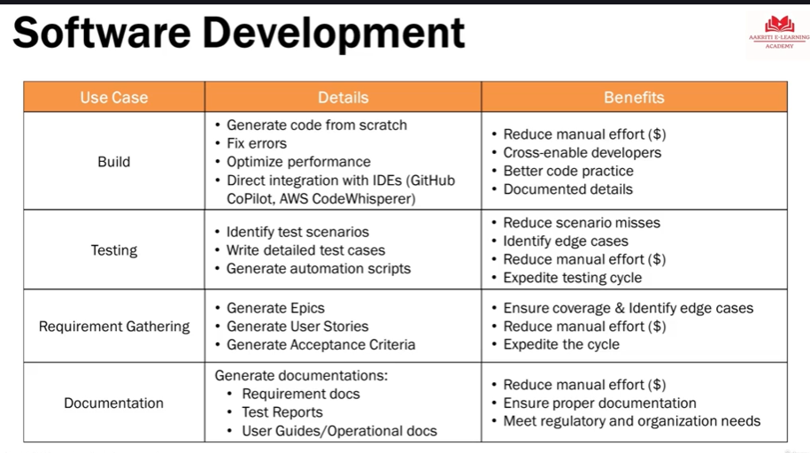

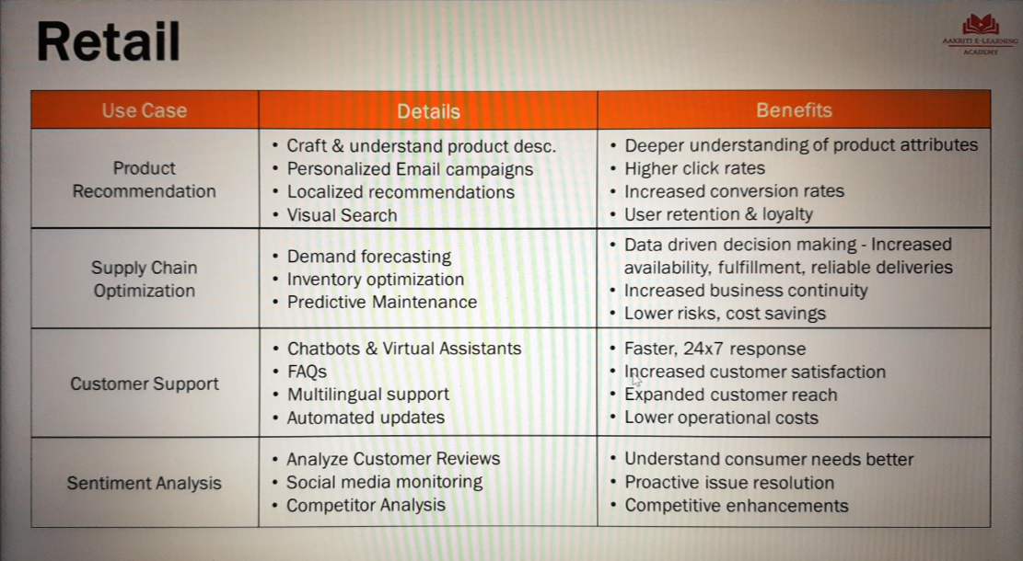
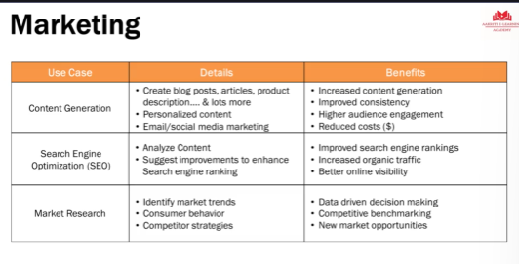

It talks about principles, guidelines, practices that you can use to make sure your AI system is fair,
it is transparent, it protects human values, and most importantly, it should not have any negative traits.

Responsible AI:
- Ethics principle
- Data quality
- Transparency
- Consistent and compliance
- Monitor and improve
- Human in loop

